 | JURNAL LINGKUNGAN BINAAN INDONESIA  ISSN Print: 2301-9247 | ISSN Online: 2622-0954 | Journal Website: http://iplbijournals.id/index.php/jlbi/index
Article’s Title (Lato 14, bold)
Author A ^{1,2}*, Author B ³, Author C ¹ (Lato 12)
¹ Department, Faculty/School, Institution, Country. (Lato 8,5)
² Department, Faculty/School, Institution, Country.
³ Department, Faculty/School, Institution, Country.

| Received May 16th 2016 | Accepted June 17th 2016 | Published June 30th 2016 |
| DOI http://dx.doi.org/10.18860/jia.v4i1.3466 |

Abstract (Lato 10, bold)
Lato 9. Use this template to write and edit articles to be submitted to the Jurnal Lingkungan Binaan Indonesia (JLBI). Submit the manuscript in English only on .docx format. Authors are required to upload two .docx files: one file containing the author identity and one anonymous file without author names. Submissions in formats other than .docx or that do not conform to this template will be automatically rejected. Submitted articles must be written on A4-sized paper, ranging from 6 to 12 pages (no more, no less), with 2 cm margins on all sides, using the specified font type and size (font: Lato), following the guidelines for the placement and labeling of tables and figures, the reference list, and other formatting requirements as demonstrated or explained in this template. The title must fit within a maximum of two lines. The abstract should be written in this section, consisting of one paragraph and a maximum of 150–200 words. The abstract briefly explains the issue/problem, objectives, data collection and analysis methods, and findings. List the keywords below the abstract, with a maximum of 5 words, arranged in alphabetical order by the first letter of each word.
Keywords : article, guide-line, journal, template, writing

Judul Artikel (Lato 14, bold, italic)
Abstrak (Lato 10, bold, italic)
Lato 9, italic. Abstrak dalam Bahasa Indonesia. Gunakan template ini untuk menulis dan mengedit artikel yang akan dikirim ke Jurnal Lingkungan Binaan Indonesia (JLBI). Kirimkan naskah dalam bahasa Inggris dan hanya dalam format .docx. Penulis diwajibkan mengunggah dua berkas .docx: satu berkas yang berisi identitas penulis dan satu berkas anonim tanpa nama penulis. Pengiriman dalam format selain .docx ataupun tidak sesuai template ini akan ditolak secara otomatis. Artikel yang dikirim harus ditulis pada kertas berukuran A4 sejumlah 6 sampai 10 halaman (tidak kurang tidak lebih) dengan margin semua sisi (2 cm), jenis dan dimensi huruf (font: Lato), tata-cara perletakan dan penulisan nama tabel dan gambar, penulisan pustaka, dan format lain-lain seperti yang dicontohkan atau dijelaskan pada template ini. Panjang judul dibatasi maksimum mengisi dua baris. Abstrak ditulis pada bagian ini, sepanjang satu paragraf dan maksimal 150-200 kata. Abstrak menjelaskan secara ringkas persoalan/ permasalahan, tujuan, metode pengumpulan dan analisis data, dan temuan. Tuliskan kata-kunci di bawah abstrak, maksimal 5 kata dan diurut mengikuti abjad huruf pertama setiap kata.
Kata-kunci : jurnal, naskah, panduan, penulisan, template

* Corresponding Author (Lato 9, bold)
E-mail : author@institution.ac.id Lato 9

All main text Lato 10. Articles submitted to Jurnal Lingkungan Binaan Indonesia (JLBI) should be research reports that provide a comprehensive yet concise explanation of the problem, literature review, objectives, data collection methods, data analysis methods, and interpretation/discussion of findings that demonstrate novelty. The novelty of the research findings is demonstrated through comparison with the current state of the art. Accepted articles are divided into three categories: Research Articles, Discourse Articles, and Research Methodology Articles.
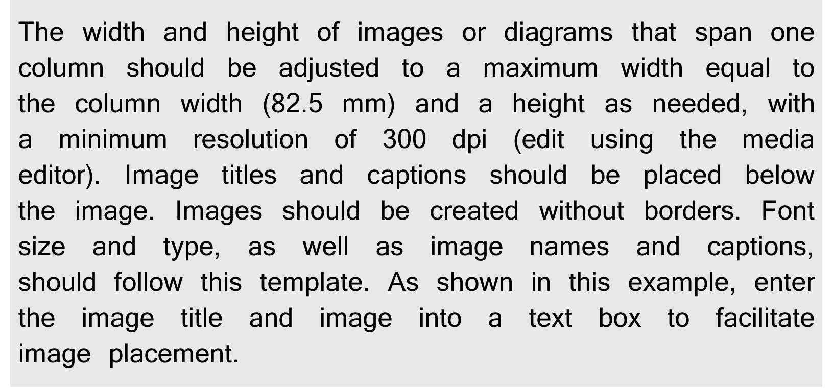
Figure 1. (Lato 8, bold) Figure/Diagram Name [1] (Lato 8)
Research Articles are working papers or drafts of research findings that can be further developed into journal articles after receiving feedback from peers during academic conferences. Discourse Articles consist of research reports or writings on ideas, with an emphasis on criticism and/or discussion of objects, subjects, and statements regarding those objects/subjects, supported by comprehensive references to current and relevant articles, well-reasoned arguments, and reliable interpretations based on the author’s perspective. Research Methodology Articles contain descriptions or discussions of paradigms, approaches, data collection methods, data analysis methods, or specific research methodology issues, accompanied by examples.
Articles should follow this structure: introduction (problem statement, literature review, objectives), methods (data collection methods and data analysis methods), results and discussion, and conclusion. The order of the sections and the naming of subsections do not have to match exactly what is written in this template; authors may determine the order and naming according to their own reasoning.
Authors must properly refer to all tables and figures within the main text. Tables and figures should not appear without explanation or reference in the manuscript. When referring to a table or figure, authors should include it as part of the sentence, for example: “As shown in Figure 1…” or “Table 2 shows that…”. Avoid referencing tables or figures only by writing (Figure 1) without explanatory text. Authors should also ensure that the reference to the table or figure and the table/figure itself are placed close to each other in the manuscript. The table or figure should not appear too far from the paragraph where it is first mentioned. If a figure, diagram, or table is originally created by the author, it is not necessary to include a source note below the figure or table. Please cite the image source if the image does not belong to the author. See Figure 1 for an example of how to cite the source. Examples of the formatting of tables, diagrams, or figures can be seen in Tables 1 and 2, or Figures 1, 2, and 3.
Table 1. (Lato 8, bold) Table Name (Lato 8)
No | Variable 1 | Variable 2 | Variable 3 | Variable 4 | Variable 5
1 | The table title and description are written above the table. The table title is in bold. The table borders consist only of horizontal borders; there are no vertical borders. The table can be created with a maximum width equal to the column width (14.2 cm). (Lato 8) | data | data | data | data
1 |  | data | data | data | data
1 |  | data | data | data | data
1 |  | data | data | data | data
2 | As shown in this example, enter the table title and table into a text box to make it easier to position the table. Use the ‘Format’ menu located at the top right of the Microsoft Word application to arrange the text box’s position. Right-click the text box and select ‘Format Shape’ to adjust the display details. | data | data | data | data
2 |  | data | data | data | data
2 |  | data | data | data | data

Introduction (Lato 10, bold)
Explain the issue, its background, the literature review, the state of the art, the research gap, the research questions, and the research objectives. The first few paragraphs of the introduction explain the issue and its background. The following paragraphs present outline the literature review and the state of the art, highlighting the latest developments in the field that are directly relevant to the issue at hand. Based on this discussion, authors should clearly identify the research gap that the study aims to address. The final paragraph of the introduction presents the research questions and describes the research objectives.

Methods (Lato 10, bold)
In this section, if necessary, the research perspective or paradigm—such as social constructivism, post-positivism, pragmatism, or advocacy/participatory—can be explained, along with the methods used: qualitative, quantitative, or mixed-methods [1]. The author may also describe the nature of the research: descriptive, exploratory, or explanatory [3], and the approach used: narrative research, phenomenology, grounded theory, ethnography, or case study [2], or correlational, experimental, or quasi-experimental research [3].

Data Collection Methods (Lato 10)
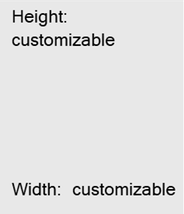
Describe the data collection methods used, such as surveys (communicating with others through listening), observation (interacting with objects/subjects through seeing/observing), or archival sources (maps, photos, books, journals, etc., understood through reading), along with details on how these methods were applied. If deemed necessary, this section may also describe the population, sample, and sampling method, as well as the timing and duration of data collection.
Figure 3a (Lato 8, bold) (left). Figure/Diagram Name (Lato 8) Figure 3b (Lato 8, bold) (left). Figure/Diagram Name (Lato 8)
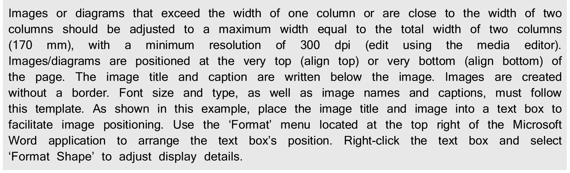
Figure 2. (Lato 8, bold) Figure/Diagram Name (Lato 8)

For research involving human participants, human data, or animals, authors must explicitly state in the manuscript whether ethical approval was obtained.
- Requirement: Authors must include a dedicated statement in the manuscript (usually within the Methods section) detailing the name of the ethics committee/institutional review board, along with the approval number and date of issuance (e.g., “Ethical approval for this study was granted by the Ethics Committee of University X, Approval No. 123/EC/2025, on May 10, 2025”).
- Exemption Statement: If the study is exempt from ethical approval or if human/animal subjects were not involved, authors must provide a clear statement explaining the justification (e.g., “Ethical clearance was not required for this study as it utilizes secondary public data/non-human subjects”).
- Reviewer/Editor Verification: Reviewers and editors will evaluate the ethical compliance of the study during the review process. Manuscripts lacking this statement for studies involving human or animal subjects will be returned for revision or desk-rejected.
Table 2. (Lato 8, bold) Table Name (Lato 8)
No | Variable 1 | Variable 2
1 | The table title and description are written above the table. The table title is in bold. The table borders consist only of horizontal borders; there are no vertical borders. The table can be created with a maximum width equal to the column width 82.5 mm. (Lato 8) | data
1 |  | data
1 |  | data
1 |  | data
1 |  | data
2 | As shown in this example, enter the table title and table into a text box to make it easier to position the table. Use the ‘Format’ menu located at the top right of the Microsoft Word application to arrange the text box’s position. Right-click the text box and select ‘Format Shape’ to adjust the display details. | data
2 |  | data
2 |  | data
2 |  | data

Data Analysis Methods (Lato 10)
Describe the data analysis methods used to reveal the research findings. Specify the qualitative or quantitative data analysis methods used to uncover the findings. Data analysis methods are tools for constructing knowledge. The content of the knowledge to be revealed (as stated in the research objectives) influences the data analysis methods employed. Supplement the article with any tables, diagrams, or figures necessary for clarification.

Result and Discussion (Lato 10, bold)
Sub-Result topic 1 (Lato 10)
This section contains the results of the analysis and an interpretation/discussion of those results. The results of the analysis may be presented in the form of diagrams, figures, tables, or other illustrations that are easy to understand and communicate. The interpretation and discussion may consist of a synthesis of the analysis results, the literature review, and the researcher’s insights. Compare the analysis results with the theories outlined in the literature review in the introduction to identify the novelty of the research. Present the discussion in a structured, comprehensive, and concise manner so that readers can follow the researcher’s analytical and interpretive reasoning.
Sub-Result topic 2 (Lato 10)
In a discourse article, the discussion may include an elaboration of the perspectives or frameworks used to perceive, analyze, and understand the object or subject, statements regarding that object or subject, or phenomena involving the object or subject. Key issues can be explained in such a way as to capture the reader’s attention, enrich the discourse, or open up new perspectives. Discourse articles present new perspectives and articulate well-reasoned arguments and reliable interpretations. References to relevant theories or principles from the reviewed literature or the opinions of peers will enhance the weight and reliability of the statements presented.
Sub-Result topic 3 (Lato 10)
Subsections (Level 2 heading) should be written in Lato, 10 pt, regular. These headings are used to divide the main sections into more specific topics.
- Sub-sub topic 1 (Lato 10)
Level 3 heading should include numbering at the beginning of the heading. The text should be indented to indicate the hierarchical structure within the subsection.
- Sub-sub-sub topic 1 (Lato 10)
Level 4 heading should be written using alphabetical markers before the heading. This level should also follow the indentation to maintain the hierarchical structure of the manuscript.
- Sub-sub-sub topic 2 (Lato 10)
Etc.

- Sub-sub topic 2 (Lato 10)
Authors are encouraged to maintain a clear and consistent hierarchy of headings throughout the manuscript to improve readability and organization.

Conclusion (Lato 10, bold)
The conclusion section briefly summarizes the research findings without adding any new interpretations. This section may also include the novelty of the findings or discourse, the strengths and weaknesses of the findings or discourse, and recommendations for future research or discourse.

AI Use Declaration (Lato 10, bold)
Authors must clearly state the use of artificial intelligence (AI) tools in the preparation of the manuscript. This includes, but is not limited to, the use of AI for translation, grammar checking, language editing, literature search, assistance, and reference formatting. AI tools should not be used for: content generation, image creation, data analysis and interpretation, or drawing conclusions. The declaration should be written transparently to ensure research integrity.
Example for manuscript using AI:
The authors acknowledge the use of [INSERT AI TOOL NAME AND VERSION, e.g., ChatGPT-4, Claude 3.5 Sonnet, Grammarly AI] to [INSERT SPECIFIC PURPOSE, e.g., translation, improve language clarity, assist with grammar checking, help organize literature review]. The prompts used are "[INSERT ACTUAL PROMPTS USED, e.g., Please proofread this text for grammar and clarity while preserving academic tone]" and "[INSERT ADDITIONAL PROMPTS IF APPLICABLE]." The output from these prompts was used to [INSERT HOW OUTPUT WAS USED, e.g., enhance grammatical accuracy, improve sentence structure, organize initial thoughts]. While the authors acknowledge the usage of AI, the authors maintain that they, [INSERT AUTHOR NAMES], are the sole authors of this article and take full responsibility for the content therein, as outlined in COPE recommendations and journal policies.
Example for manuscript not using AI:
No artificial intelligence tools were used in the preparation of this manuscript.

Acknowledgement (Lato 10, bold)
This section should be used to acknowledge individuals, institutions, or organizations that contributed to the research but are not listed as authors. This may include technical assistance, academic support, or other contributions.

Funding (Lato 10, bold)
Authors must disclose all sources of financial support for the research. This includes grants, institutional funding, or other financial contributions. If there is no funding, authors should state: “This research received no external funding.”

References (Lato 10, bold)
[1] J.W. Creswell,. Research Design: Qualitative, Quantitative, and Mixed Methods Approaches. California: Sage Publications, Inc., 2008 (Lato 9)
[2] J.W. Creswell, Qualitative Inquiry & Research Design: Choosing Among Five Approches. California: Sage Publications, Inc., 2012.
[3] Groat, L. & Wang, D. Architectural Research Methods. New York: John Wiley & Sons. Inc., 2002.

Citations and the reference list must follow IEEE style, and the use of reference management tools such as Mendeley and/or Zotero is required. The manuscript must include at least 15 valid and traceable references with 80% of the references must consist of journal articles, conference proceedings, or research findings from the past ten years. The remaining 20% may consist of books, newspapers, or online sources, which must include the website URL and the date of access. Avoid sources from Wikipedia. All references must include DOI and source links.

