 | JURNAL LINGKUNGAN BINAAN INDONESIA  ISSN Print: 2301-9247 | ISSN Online: 2622-0954 | Journal Website: http://iplbijournals.id/index.php/jlbi/index
This is Title
My Name ^{1,3}*, Colleague Name ², Colleague Name ¹
¹ Department Architecture, School of Design, Institution A, Indonesia.
² Department of Informatic Science, School of Informatics, Institution B, Malaysia.
³ Department of Architecture, Faculty of Engineering, Institution C, Indonesia.

| Received May 16th 2016 | Accepted June 17th 2016 | Published June 30th 2016 |
| DOI http://dx.doi.org/10.18860/jia.v4i1.3466 |

Abstract
The abstract is written in this section as a single paragraph of 150–200 words. It briefly outlines the research problem or issue (1–3 sentences), the objective (1 sentence), the data collection and analysis methods (1–2 sentences), and the findings (1 sentence). List up to five keywords below the abstract; select significant terms that will help the manuscript appear in search engine results when other authors search for those specific terms. Keywords should ideally be arranged in alphabetical order. Aim to meet the 150–200 word requirement, and avoid simply copying sentences from the introduction, which would result in repetition. Abstract. Abstract. Abstract. Abstract. Abstract. Abstract. Abstract. Abstract. Abstract. Abstract. Abstract. Abstract. Abstract. Abstract. Abstract. Abstract. Abstract. Abstract. Abstract. Abstract. Abstract. Abstract. Abstract. Abstract. Abstract. Abstract. Abstract. Abstract. Abstract. Abstract. Abstract. Abstract. Abstract. Abstract. Abstract. Abstract. Abstract. Abstract. Abstract. Abstract..
Keywords : article, guide-line, journal, template, writing

Ini Judul Artikel
Abstrak
Abstrak dalam Bahasa Indonesia. Gunakan template ini untuk menulis dan mengedit artikel yang akan dikirim ke Jurnal Lingkungan Binaan Indonesia (JLBI). Kirimkan naskah dalam bahasa Inggris dan hanya dalam format .docx. Penulis diwajibkan mengunggah dua berkas .docx: satu berkas yang berisi identitas penulis dan satu berkas anonim tanpa nama penulis. Pengiriman dalam format selain .docx ataupun tidak sesuai template ini akan ditolak secara otomatis. Artikel yang dikirim harus ditulis pada kertas berukuran A4 sejumlah 6 sampai 10 halaman (tidak kurang tidak lebih) dengan margin semua sisi (2 cm), jenis dan dimensi huruf (font: Lato), tata-cara perletakan dan penulisan nama tabel dan gambar, penulisan pustaka, dan format lain-lain seperti yang dicontohkan atau dijelaskan pada template ini. Panjang judul dibatasi maksimum mengisi dua baris. Abstrak ditulis pada bagian ini, sepanjang satu paragraf dan maksimal 150-200 kata. Abstrak menjelaskan secara ringkas persoalan/ permasalahan, tujuan, metode pengumpulan dan analisis data, dan temuan. Tuliskan kata-kunci di bawah abstrak, maksimal 5 kata dan diurut mengikuti abjad huruf pertama setiap kata.
Kata-kunci : jurnal, naskah, panduan, penulisan, template

* Corresponding Author
E-mail : author@institution.ac.id

Introduction
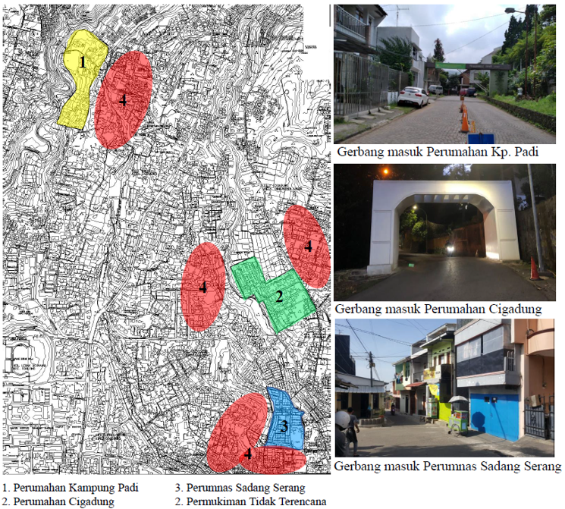
Figure 1. Location and gate for residence A

The introduction begins with the research background or the discourse to be addressed. Avoid statements based on personal opinions by providing reliable data sources so that the statements remain accountable [1], [2]. The cited references should preferably consist of relatively recent journal articles published within the last 10 years [3]. Authors are also encouraged to manage references using reference manager applications such as Mendeley, EndNote, or Zotero. All sources must be traceable and verifiable. Upon manuscript acceptance, the JLBI editorial team will contact the authors to verify the references used. Please provide an active and reachable WhatsApp number to facilitate communication with the editorial team.
In the second paragraph, present a description of the specific problem to be investigated in relation to the phenomenon outlined in the first paragraph. Please note that a standard paragraph should consist of multiple sentences rather than a single sentence. However, avoid overly lengthy paragraphs, as this may obscure the core problem. Alternatively, this second paragraph may be merged with the background section in the first paragraph to make it more concise.
The third paragraph focuses on literature support, detailing previous studies conducted by other researchers on similar issues, or establishing the theoretical foundation related to the raised phenomenon [4]-[7]. Essentially, this paragraph should demonstrate the state of the art or the novelty of the author's manuscript. Explain how this research differs from existing studies. This section may span across multiple paragraphs, depending on the complexity of the theories discussed.
The fourth paragraph contains the statement of the research objectives [5]. Clearly and concisely explain the expected outcomes and the implications of the research on existing theories or scientific knowledge.

Methods
Clearly describe the research methods applied. Begin by stating the location or site where the research was conducted, supported by a location map, situational overview, or similar visuals. When including figures, provide a description so that each image or photo genuinely contributes to the explanation in the manuscript. All figures and tables must be cited and discussed within the text. For example: "Figure 1 illustrates the research location situated in Village X, City Y."
Also, explain how the data was acquired. If interviews were conducted, detail the interview process, the timing, whether surveyor assistance was involved, and other relevant procedural details. In the subsequent paragraph, explain how the data analysis was performed.

Data Collection Methods
Describe the data collection methods used, such as surveys (communicating with others through listening), observation (interacting with objects/subjects through seeing/observing), or archival sources (maps, photos, books, journals, etc., understood through reading), along with details on how these methods were applied such as in Figure 2. If deemed necessary, this section may also describe the population, sample, and sampling method, as well as the timing and duration of data collection. Ethical clearance was not required for this study as it utilizes non-human subjects

Result and Discussion
Sub-Result 1
Divide the results and discussion into several sub-sections. Construct each sub-section with a topic sentence that highlights key findings and opens up discussion. If presenting data using tables, format them to fit within a single column; however, if a table is too wide, it may span across two columns. Tables must be created without vertical borders or outer side borders, as shown in Example Table 1.
Sub-Result 2
Figure 2. Location and gate for different residence

Analysis results can be presented using diagrams, figures, tables, or other illustrative formats that are clear and easy to communicate. The interpretation and discussion should synthesize the analysis findings, literature review, and the authors' critical insights. Compare your findings against the theories outlined in the introduction to establish the novelty of your research. Present your discussion in a structured, comprehensive, and concise manner so that readers can follow your analytical and interpretive flow smoothly.
Table 1. Characteristics of Residences
 | Kampung Padi | Perumahan Cigadung | Perumnas Sadang Serang
Location | Kampung Padi Street, Dago, Bandung | Cigadung Street, Bandung | Sadang Serang Street, Bandung
Natural Condition | Contoured | Contoured | Not Contoured
Occupant Characteristics | Homogen, Elderly Group | Heterogen, Working Group | Heterogen, Elderly Group and Working Group
Characteristics of the Surrounding Residential Environment | Encompassed by unplanned settlements with indistinct boundaries. | Surrounded by unplanned settlements with indistinct boundaries and bordering an Islamic boarding school area. | It is close to unplanned settlements and clearly bounded by a road.

Sub-Result 3
For discourse-based articles, the discussion may elaborate on the perspectives or analytical frameworks used to perceive, unpack, and understand the subject/object, as well as the statements or phenomena surrounding it. Key nodes of the issue should be articulated in a way that engages readers, enriches discourse, or opens new perspectives. A discourse article presents new viewpoints built on robust arguments and reliable interpretations. Citing relevant theories or principles from the literature, as well as peer insights, will enhance the academic weight and reliability of the statements presented.

Conclusion
In the conclusion section, summarize the research findings concisely without introducing new interpretations. This section should also highlight the novelty of the findings or discourse, outline the strengths and limitations of the study, and provide recommendations for future research or discourse. No references or literature citations should be included in the conclusion.

AI Use Declaration
The authors acknowledge the use of Gemini AI to improve language clarity and assist with grammar checking. While the authors acknowledge the usage of AI, the authors maintain that they are the sole authors of this article and take full responsibility for the content therein, as outlined in COPE recommendations and journal policies.

Acknowledgement
This section should be used to acknowledge individuals, institutions, or organizations that contributed to the research but are not listed as authors. This may include technical assistance, academic support, or other contributions.

Funding
This research received no external funding.

Reference
[1] J. Strømann-Andersen and P. A. Sattrup, “The urban canyon and building energy use: Urban density versus daylight and passive solar gains,” Energy Build., vol. 43, no. 8, pp. 2011–2020, Aug. 2011, doi: 10.1016/j.enbuild.2011.04.007.
[2] A. E. Maier and A. Maier, “Special Issue-International Workshop in Architecture and Urban Planning Sustainable Development and the Built Environment Daylight as Starting Point For Retrofitting Residential Buildings and Cities,” 2015.
[3] T. Dogan and Y. C. Park, “A New Framework for Residential Daylight Performance Evaluation Performance Driven Design View project Architectural building energy modeling View project.” [Online]. Available: https://www.researchgate.net/publication/319097274
[4] N. L. A. Widyahari and P. N. Indradjati, “The Potential of Transit-Oriented Development (TOD) and its Opportunity in Bandung Metropolitan Area,” Procedia Environ. Sci., 2015, doi: 10.1016/j.proenv.2015.07.057.
[5] V. Cheng, K. Steemers, M. Montavon, and R. Compagnon, “Compact cities in a sustainable manner,” 2006.
[6] O. Lami, “Daylighting and sunlighting in street canyons A quantitative research on the visual perception and in-situ daylight measurements of four urban canyons in Copenhagen.”
[7] J. A. Veitch, M. G. M. Stokkermans, and G. R. Newsham, “Linking Lighting Appraisals to Work Behaviors,” Environ. Behav., vol. 45, no. 2, pp. 198–214, Feb. 2013, doi: 10.1177/0013916511420560.

